Name: Charles Taggart
Course / Cohort: FSDI-109 Cohort 65
Assignment: FSDI 109 React Project with Routing
GitHub Repository Link:
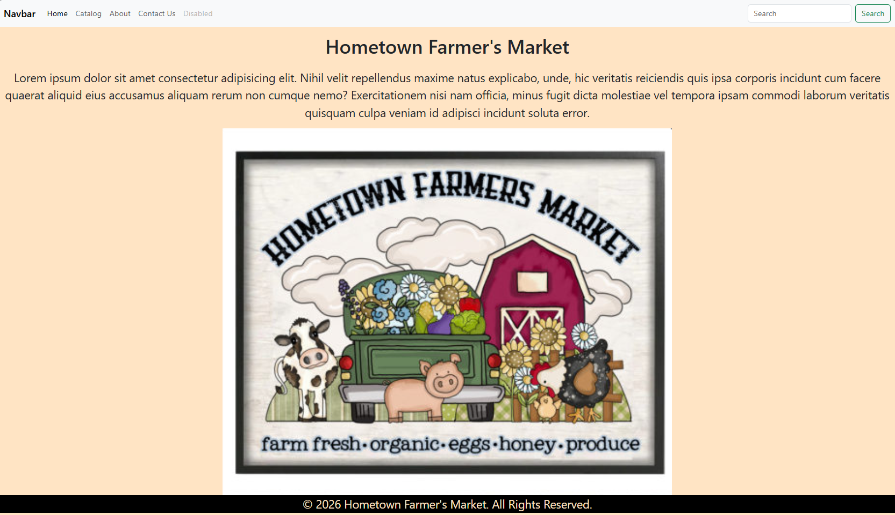

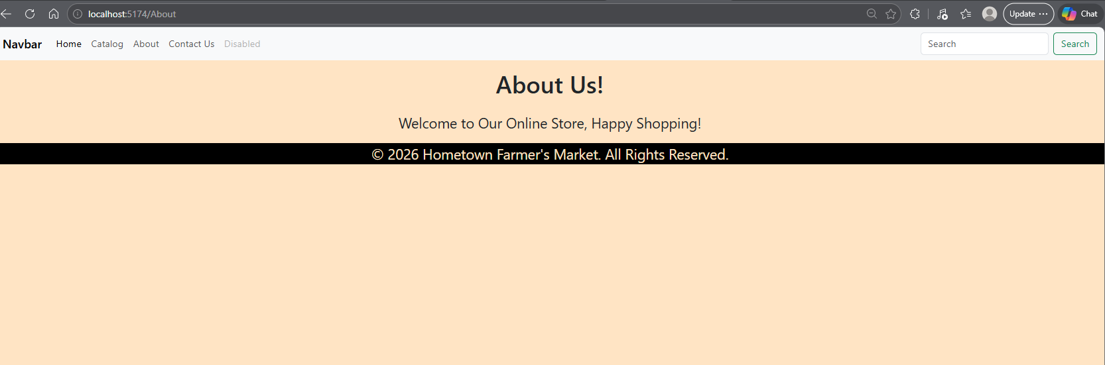
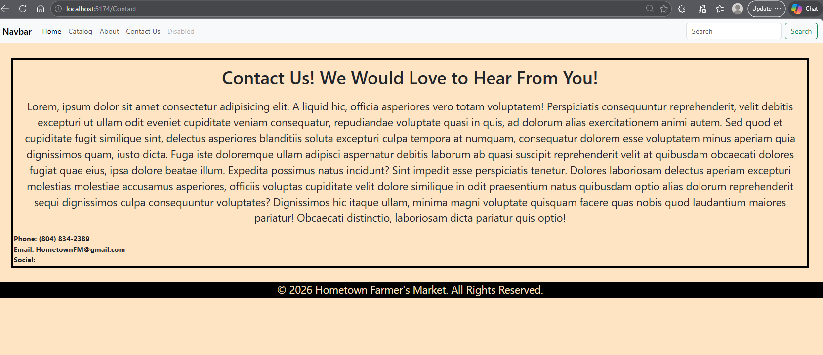
Summary of Edits:
- Added some css to all pages
- Created a Contact page
- Linked contact page with Navbar
AI Disclosure (Required) – Highlight the one that applies
• I did not use AI
• I used AI for help
• AI generated parts of my code

